**MACHINE LEARNING BASED DIAGNOSIS OF LUMPY SKIN**

**DISEASE**

|  |  |
| --- | --- |
| **CONTENT** | **PAGE NO** |
| **Abstract** |  |
| **1.INTRODUCTION** |  |
| 1.1 Motivation |  |
| 1.2 Problem Statement |  |
| 1.3 Objective of the Project |  |
| 1.4 Scope |  |
| 1.5 Project Introduction |  |
| **2.** **2. LITERATURE SURVEY** |  |
| 2.1 Related Work |  |
| **3. SYSTEM ANALYSIS** |  |
| 3.1 Existing System |  |
| 3.2 Disadvantages |  |
| 3.3 Proposed System |  |
| 3.4 Advantages |  |
| 3.5 work Flow of Proposed system |  |
| **4. REQUIREMENT ANALYSIS** |  |
| 4.1Function and non-functional requirements |  |
| 4.2 Hardware Requirements |  |
| 4.3 Software Requirements |  |
| 4.4 Architecture |  |
| **5. SYSTEM DESIGN** |  |
| 5.1 Introduction of Input design |  |
| 5.2 UML Diagram(class, use case, sequence, collaborative, deployment, activity, ER diagram and Component diagram) |  |
| 5.3 Data Flow Diagram |  |
| **6. IMPLEMENTATION AND RESULTS** |  |
| 6.1 Modules |  |
| 6.2 Output Screens |  |
| 1. **SYSTEM STUDY AND TESTING** |  |
| 7.1 Feasibility study |  |
| 7.2 Types of test & Test Cases |  |
| **8. CONCLUSION** |  |
| **9. FUTURE ENHANCEMENT** |  |
| **10. REFERENCES** |  |

**ABSTRACT**

Lumpy Skin Disease (LSD) is a highly contagious viral infection that significantly impacts cattle, posing a serious threat to the global livestock industry. Rapid and accurate diagnosis of LSD is critical to controlling its spread and preventing substantial economic losses. Traditional diagnostic methods, such as clinical observation and laboratory testing, are time-consuming and may lack the sensitivity required for early detection. This paper presents a novel approach for the diagnosis of Lumpy Skin Disease using machine learning (ML) techniques. We utilized a comprehensive dataset, including images and clinical data of cattle affected by LSD, alongside data from healthy cattle for comparison, sourced from Kaggle's Lumpy Skin Disease Prediction dataset.

The study employs Convolutional Neural Networks (CNNs) and MobileNet for image classification, where the models are trained to distinguish between Lumpy Skin Disease and normal cattle images. The CNNs, specifically MobileNet, are chosen for their ability to efficiently extract features from the images, enabling the system to classify the images accurately and rapidly. This ML-based diagnostic system offers two primary advantages: First, it provides a fast and non-invasive method for detecting LSD, significantly reducing the time required for diagnosis compared to traditional methods. This speed is essential for implementing timely control measures to prevent the disease's spread. Second, the high accuracy of the model ensures reliable results, minimizing the risk of misdiagnosis and subsequent economic losses. The integration of advanced ML models with a robust dataset contributes to the accuracy and efficiency of the system, with the potential to transform the management and detection of Lumpy Skin Disease. This approach not only enhances the health and productivity of cattle populations but also supports the livestock industry's efforts to control this devastating disease.

Keywords: Lumpy Skin Disease, CNN, MobileNet, Image Classification, Machine Learning, Diagnosis, Dataset, Livestock, Economic Impact.

1. **INTRODUCTION**

**1.1 Motivation:**

Lumpy Skin Disease (LSD) poses a significant threat to the global livestock industry, particularly in cattle, leading to both economic losses and reduced productivity. Traditional diagnostic methods for LSD are time-consuming, expensive, and often lack sensitivity. The urgency for rapid and accurate diagnosis has driven the exploration of machine learning (ML) techniques as a potential solution. Leveraging ML models like Convolutional Neural Networks (CNNs) and MobileNet can enable quicker, more reliable detection, ultimately assisting in better disease management and prevention. With the growing availability of large-scale datasets, we are motivated to explore how these advanced techniques can be integrated to enhance early detection of LSD and prevent its widespread impact on livestock.

**1.2 Problem Statement:**

Lumpy Skin Disease (LSD) continues to pose a major challenge in livestock management due to its contagious nature and significant economic impact. Traditional diagnostic techniques for LSD, such as clinical observation and laboratory testing, are not only slow but can also be prone to errors, delaying timely interventions. There is a clear need for faster, more reliable diagnostic systems that can automatically and accurately identify LSD in cattle based on image data. This project addresses this gap by developing a machine learning-based model that leverages advanced image classification techniques to detect LSD more efficiently and effectively.

**1.3 Objective of the Project:**

The primary objective of this project is to develop a machine learning-based system that can accurately detect Lumpy Skin Disease (LSD) in cattle using images. By implementing Convolutional Neural Networks (CNNs) and MobileNet, the project aims to achieve a high level of accuracy in classifying cattle images as either LSD-affected or healthy. The system will be evaluated for its performance in terms of accuracy, precision, and recall, ensuring it meets the requirements for real-world application in veterinary and agricultural practices.

**1.4 Scope:**

This project focuses on developing a robust machine learning model for the rapid and accurate classification of Lumpy Skin Disease (LSD) in cattle using image data. The scope includes data preprocessing, feature extraction, and training CNN models, specifically MobileNet, to distinguish between LSD-affected cattle and healthy cattle. The dataset used is sourced from Kaggle's Lumpy Skin Disease Prediction competition, and the models will be evaluated based on their accuracy and robustness in real-world scenarios. The project aims to provide a scalable solution for integrating ML-based systems into veterinary practices and agricultural sectors to help in early disease detection and management.

**1.5 Project Introduction:**

Lumpy Skin Disease (LSD) is a viral infection that significantly affects cattle, leading to severe economic losses and disruptions in the livestock industry. Rapid diagnosis of LSD is essential for controlling its spread, but traditional methods often lack speed and precision. This project proposes the use of machine learning techniques, specifically Convolutional Neural Networks (CNNs) and MobileNet, for the automated detection of LSD in cattle images. By utilizing a comprehensive dataset from the Kaggle Lumpy Skin Disease Prediction competition, this project aims to develop a fast, reliable, and accurate diagnostic system that can assist in the early detection of LSD, minimizing the risks of misdiagnosis and delays in intervention. The system's effectiveness will be measured through various metrics such as accuracy, precision, and recall, ensuring its robustness for real-world use in agricultural and veterinary sectors.

1. **LITERATURE SURVEY**

**2.1 Related Work:**

**[1] Y. Casali, N.A. Yonca, T. Comes and Y. Casali, “Machine learning for spatial analyses in urban areas: a scoping review,” Sustainable Cities and Society, vol. 85, pp.104050, 2022.**

The challenges for sustainable cities to protect the environment, ensure economic growth, and maintain social justice have been widely recognized. Along with the digitization, availability of large datasets, Machine Learning (ML) and Artificial Intelligence (AI) are promising to revolutionize the way we analyze and plan urban areas, opening new opportunities for the sustainable city agenda. Especially urban spatial planning problems can benefit from ML approaches, leading to an increasing number of ML publications across different domains. What is missing is an overview of the most prominent domains in spatial urban ML along with a mapping of specific applied approaches. This paper aims to address this gap and guide researchers in the field of urban science and spatial data analysis to the most used methods and unexplored research gaps. We present a scoping review of ML studies that used geospatial data to analyze urban areas. Our review focuses on revealing the most prominent topics, data sources, ML methods and approaches to parameter selection. Furthermore, we determine the most prominent patterns and challenges in the use of ML. Through our analysis, we identify knowledge gaps in ML methods for spatial data science and data specifications to guide future research.

**[2] R. Gupta, A. Sharma, S. Gupta, M. Garg and G. Kaur, "Automatic Identification of Paddy Crop Diseases using Deep Learning Approach," in Proc. 3rd International Conference on Electronics and Sustainable Communication Systems (ICESC), Coimbatore, India, 2022, pp. 915-920**

In agriculture sciences, due to the complexity and localized subtleties of the crops, crop products, and worm insects that cause disease, disease identification is one of the most difficult tasks. Even agriculture professionals and botanists require assistance from a variety of sources to diagnose unusual plant diseases. As a result, a marginal farmer may be unable to detect the disease and, as a result, may use excessive or incorrect pesticides. In order to prevent his crop from going to waste, he must seek expert guidance to precisely detect the condition and seek advice on how to treat it.The proposed paper design a technological solution by providing a deep learning based Convolutional Neural Network (CNN) algorithm for the detection of different type of diseases such as Rice stripe virus disease (RSVD), Sheath Blight, Blast, Rice Tungro and Brown Spot in Paddy crop. The system shall also incorporate the designing of Geo-referenced Pest Infestation Map (PIM) for the cultivated area in three districts named as Patiala, Sangrur and Fathegarh Sahib of Punjab state in India. This PIM will be created for 10 Hectare land for each district. It will aid in controlled spraying of the pesticides.

**[3] S. Singh, I. Gupta, S. Gupta, D. Koundal, S. Aljahdali, S. Mahajan and A.K Pandit, “Deep learning based automated detection of diseases from apple leaf images,” CMC-Computers,Materials & Continua, vol. 71, no.1, pp.1849-1866, 2022.**

In Agriculture Sciences, detection of diseases is one of the most challenging tasks. The mis-interpretations of plant diseases often lead to wrong pesticide selection, resulting in damage of crops. Hence, the automatic recognition of the diseases at earlier stages is important as well as economical for better quality and quantity of fruits. Computer aided detection (CAD) has proven as a supportive tool for disease detection and classification, thus allowing the identification of diseases and reducing the rate of degradation of fruit quality. In this research work, a model based on convolutional neural network with 19 convolutional layers has been proposed for effective and accurate classification of Marsonina Coronaria and Apple Scab diseases from apple leaves. For this, a database of 50,000 images has been acquired by collecting images of leaves from apple farms of Himachal Pradesh (H.P) and Uttarakhand (India). An augmentation technique has been performed on the dataset to increase the number of images for increasing the accuracy. The performance analysis of the proposed model has been compared with the new two Convolutional Neural Network (CNN) models having 8 and 9 layers respectively. The proposed model has also been compared with the standard machine learning classifiers like support vector machine, k-Nearest Neighbour, Random Forest and Logistic Regression models. From experimental results, it has been observed that the proposed model has outperformed the other CNN based models and machine learning models with an accuracy of 99.2%.

**[4] K. Al-Salihi, “Lumpy skin disease: Review of literature,” Mirror of research in veterinary sciences and animals, vol.3, no. 3, pp.6-23 2021**

Lumpy skin disease (LSD) causes huge economic losses in the livestock industry. It is caused by Lumpy skin disease virus (LSDV), which belongs to the family Poxviridae, with the Neethling strain the prototype. LSDV belongs to the genus Capripoxvirus that includes sheep pox virus and goat pox virus. LSD is an enzootic infectious, eruptive and seldom fatal disease of cattle characterised by nodules on the skin. Cattle and water buffalo are the only animal species affected, with high morbidity rate, but low mortality, however, death rates are higher among calves. LSD causes loss of milk and beef production, abortions in females and sterility in males. The original foci of LSD are from Zambia in 1929. LSD is considered as an endemic disease in the African continent. However, the disease has been moved beyond Africa in 1984. It is reported in Madagascar and some countries in the Arab Gulf Peninsula and Middle East. Recently, the disease has been reported in LSD free countries (Jordan, Syria, Lebanon, Turkey, Iran and Iraq) with potential economic loss to the livestock industry. This review article intends to discuss the LSD in the light of the recent situation raises concerns the spreading of the disease in LSD free countries.

**[5] O. Nkiruka, R. Prasad and O. Clement, “Prediction of malaria incidence using climate variability and machine learning” Informatics in Medicine Unlocked, vol. 22, pp.100508, 2021.**

Malaria remains a serious obstacle to socio-economic development in Africa. It was estimated that about 90% of the deaths occurred in Africa, where various factors such as ecosystem and climate conditions are favorable to species of mosquitoes transmitting the malaria [parasite](https://www.sciencedirect.com/topics/medicine-and-dentistry/parasite-microbiology). Some malaria epidemic prediction systems have been built to mitigate the increase of the disease outbreaks in some African countries; however, there is a need for better models with improved prediction ability based on non-seasonal variations in climatic conditions. This research proposes a machine learning-based model for the classification of malaria incidence using climate variability across six countries of Sub-Saharan Africa over a period of twenty-eight years. The work begins with a feature engineering process, which identifies the climate factors that affect the incidence of malaria, followed by the k-means [clustering process](https://www.sciencedirect.com/topics/computer-science/clustering-process) for [outlier detection](https://www.sciencedirect.com/topics/computer-science/outlier-detection), and then, [XGBoost](https://www.sciencedirect.com/topics/computer-science/extreme-gradient-boosting" \o "Learn more about XGBoost from ScienceDirect's AI-generated Topic Pages) algorithm for classification. The results suggest that although the exact association between malaria incidence and climate variability varies from one geographic region to another, the non-seasonal changes in three climatic factors (precipitation, temperature, and surface radiation) significantly contribute to the outbreak of malaria. The proposed system was compared with other [classification models](https://www.sciencedirect.com/topics/computer-science/classification-models), and the comparative results showed that the proposed system outperformed other classification models. The malaria incidence classification model is an early detection mechanism that helps to monitor the spread of malaria; it is a unique data-driven knowledge discovery system that will assist [public health](https://www.sciencedirect.com/topics/medicine-and-dentistry/public-health) authorities in learning the effects of climate factors on health and also in developing relevant preventive and adaptive mechanisms to ensure a timelier health service in order to save lives

**[6]** **E. Afshari Safavi, “Assessing machine learning techniques in forecasting lumpy skin disease occurrence based on meteorological and geospatial features,” Tropical Animal Health and Production, vol 54, no. 1, pp.55, 2022.**Lumpy skin disease virus (LSDV) causes an infectious disease in cattle. Due to its direct relationship with the survival of arthropod vectors, geospatial and climatic features play a vital role in the epidemiology of the disease. The objective of this study was to assess the ability of some machine learning algorithms to forecast the occurrence of LSDV infection based on meteorological and geological attributes. Initially, ExtraTreesClassifier algorithm was used to select the important predictive features in forecasting the disease occurrence in unseen (test) data among meteorological, animal population density, dominant land cover, and elevation attributes. Some machine learning techniques revealed high accuracy in predicting the LSDV occurrence in test data (up to 97%). In terms of area under curve (AUC) and F1 performance metric scores, the artificial neural network (ANN) algorithm outperformed other machine learning methods in predicting the occurrence of LSDV infection in unseen data with the corresponding values of 0.97 and 0.94, respectively. Using this algorithm, the model consisted of all predictive features and the one which only included meteorological attributes as important features showed similar predictive performance. According to the findings of this research, ANN can be used to forecast the occurrence of LSDV infection with high precision using geospatial and meteorological parameters. Applying the forecasting power of these methods could be a great help in conducting screening and awareness programs, as well as taking preventive measures like vaccination in areas where the occurrence of LSDV infection is a high risk.

**3. SYSTEM ANALYSIS**

**3.1 Existing System**

Current methods for LSD diagnosis in cattle rely on clinical observation and laboratory testing, which can be time-consuming and subjective. Machine learning algorithms, such as Random Forest, Decision Tree, k-NN, and AdaBoost, have been explored to automate the diagnostic process. However, these methods have limitations, including the need for substantial labeled data and potential overfitting issues.

**3.2** **Disadvantages**

1. **Limited Data Availability:** Machine learning models require large and diverse datasets to perform well. In the case of lumpy skin diseases, obtaining a sufficiently large dataset with labeled and accurate data can be challenging. Limited data can lead to overfitting and reduced model performance.
2. **Lack of Interpretability**: Machine learning models, particularly complex ones like deep learning, are often seen as "black boxes" because it can be difficult to interpret how they arrive at a diagnosis. This lack of interpretability can make it challenging for clinicians to trust and understand the model's decisions.
3. **Data Bias:** If the training data used for the machine learning model is not representative of the population or contains biased information, the model can inherit and propagate those biases. This can result in inaccurate diagnoses and potentially perpetuate disparities in healthcare.
4. **Continual Model Maintenance**: Machine learning models require continual updates and maintenance to remain effective over time. As new data becomes available and as diseases evolve, the model needs to adapt. This requires ongoing resources and expertise.
5. **Ethical and Privacy Concerns:** Handling patient data for machine learning diagnosis raises significant ethical and privacy concerns. Ensuring the security and privacy of patient information is crucial, and any breaches or misuse of data can lead to legal and ethical consequences.

**3.3 Proposed System**

The proposed system leverages advanced machine learning (ML) and deep learning algorithms specifically Multi-Layer Perceptron (MLP), Extra Tree, Naive Bayes, Convolutional Neural Networks (CNN), and MobileNet to accurately diagnose Lumpy Skin Disease by analyzing buffalo skin images. These combined methods excel at handling diverse and complex datasets, enabling rapid and reliable classification of diseased versus healthy samples. Moreover, MLP, Extra Tree, and Naive Bayes require fewer hyperparameters, enhancing ease of implementation and reducing computational overhead. Meanwhile, CNN and MobileNet architectures further refine diagnosis by extracting detailed visual features from images, resulting in highly accurate and robust classification. This system’s faster, more accessible approach promises to significantly improve LSD detection and management in real-world scenarios.

**Advantages**

1. **Early Detection**: Machine learning models, particularly CNNs and MobileNet, can efficiently analyze large amounts of image data, enabling the early detection of Lumpy Skin Disease in cattle. Early detection plays a crucial role in improving treatment outcomes and preventing the disease from spreading.
2. **Accuracy**: CNNs, MobileNet, and hybrid models excel at identifying subtle features and patterns in images that may be challenging for human clinicians to detect, such as small variations in skin lesions. This high level of accuracy reduces the risk of misdiagnosis and ensures reliable results.
3. **Efficiency**: The ML-based diagnostic system automates the process of analyzing cattle images, which speeds up the diagnosis. This automation not only saves time for veterinarians but also facilitates quicker decision-making for appropriate intervention.
4. **Data-driven Insights**: Machine learning models can analyze extensive datasets of cattle images and clinical data, providing insights into hidden patterns and correlations. This can help researchers better understand the factors contributing to LSD and improve strategies for its control and prevention.
5. **Scalability**: The machine learning approach can be easily scaled to handle large volumes of image data, making it suitable for both small veterinary practices and large agricultural operations. As more data is collected, the system's accuracy and diagnostic capability can continually improve, ensuring its long-term effectiveness in LSD detection.

**3.5 work Flow of Proposed system**

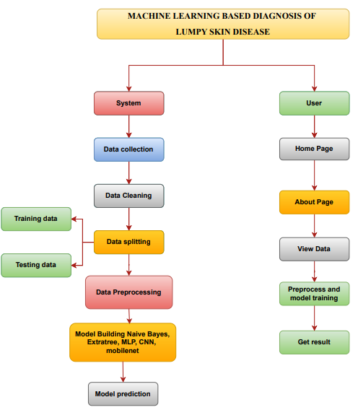

**4. REQUIREMENT ANALYSIS**

**4.1 Functional and non-functional requirements**

Requirement’s analysis is very critical process that enables the success of a system or software project to be assessed. Requirements are generally split into two types: Functional and non-functional requirements.

**Functional Requirements**: These are the requirements that the end user specifically demands as basic facilities that the system should offer. All these functionalities need to be necessarily incorporated into the system as a part of the contract. These are represented or stated in the form of input to be given to the system, the operation performed and the output expected. They are basically the requirements stated by the user which one can see directly in the final product, unlike the non-functional requirements.

Examples of functional requirements:

1. Authentication of user whenever he/she logs into the system
2. System shutdown in case of a cyber-attack
3. A verification email is sent to user whenever he/she register for the first time on some software system.

**Non-functional requirements**: These are basically the quality constraints that the system must satisfy according to the project contract. The priority or extent to which these factors are implemented varies from one project to other. They are also called non-behavioral requirements.  
They basically deal with issues like:

* Portability
* Security
* Maintainability
* Reliability
* Scalability
* Performance
* Reusability
* Flexibility

Examples of non-functional requirements:

1. Emails should be sent with a latency of no greater than 12 hours from such an activity.
2. The processing of each request should be done within 10 seconds
3. The site should load in 3 seconds whenever of simultaneous users are > 10000
   1. **Hardware Requirements**

# Processor - I3/Intel Processor

Hard Disk - 160GB

Key Board - Standard Windows Keyboard

Mouse - Two or Three Button Mouse

Monitor - SVGA

RAM - 8GB

* 1. **Software Requirements:**

Operating System : Windows 7/8/10

Server side Script : HTML, CSS, Bootstrap & JS

Programming Language : Python

Libraries : Flask, Pandas, Mysql.connector, Os, Smtplib, Numpy

IDE/Workbench : PyCharm

Technology : Python 3.6+

Server Deployment : Xampp Server

Database : MySQL

* 1. **Architecture:**

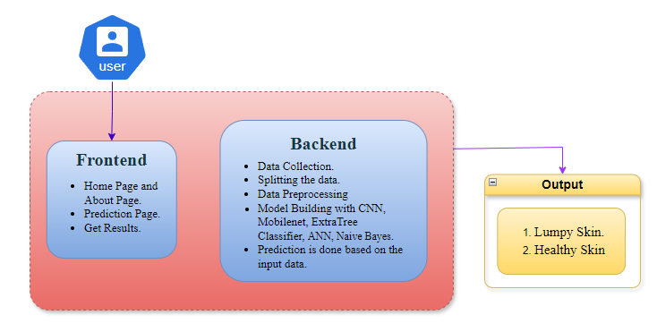

**5. SYSTEM DESIGN**

**5.1 Introduction of Input Design:**

In an information system, input is the raw data that is processed to produce output. During the input design, the developers must consider the input devices such as PC, MICR, OMR, etc.

Therefore, the quality of system input determines the quality of system output. Well-designed input forms and screens have following properties −

* It should serve specific purpose effectively such as storing, recording, and retrieving the information.
* It ensures proper completion with accuracy.
* It should be easy to fill and straightforward.
* It should focus on user’s attention, consistency, and simplicity.
* All these objectives are obtained using the knowledge of basic design principles regarding −
  + What are the inputs needed for the system?
  + How end users respond to different elements of forms and screens.

### **Objectives for Input Design:**

The objectives of input design are −

* To design data entry and input procedures
* To reduce input volume
* To design source documents for data capture or devise other data capture methods
* To design input data records, data entry screens, user interface screens, etc.
* To use validation checks and develop effective input controls.

**Output Design:**

The design of output is the most important task of any system. During output design, developers identify the type of outputs needed, and consider the necessary output controls and prototype report layouts.

### Objectives of Output Design:

The objectives of input design are:

* To develop output design that serves the intended purpose and eliminates the production of unwanted output.
* To develop the output design that meets the end user’s requirements.
* To deliver the appropriate quantity of output.
* To form the output in appropriate format and direct it to the right person.
* To make the output available on time for making good decisions.

**5.2 UML Diagrams:**

**5.2.1 Use Case Diagram:**

A use case diagram in the Unified Modeling Language (UML) is a type of behavioral diagram defined by and created from a Use-case analysis. Its purpose is to present a graphical overview of the functionality provided by a system in terms of actors, their goals (represented as use cases), and any dependencies between those use cases. The main purpose of a use case diagram is to show what system functions are performed for which actor. Roles of the actors in the system can be depicted.

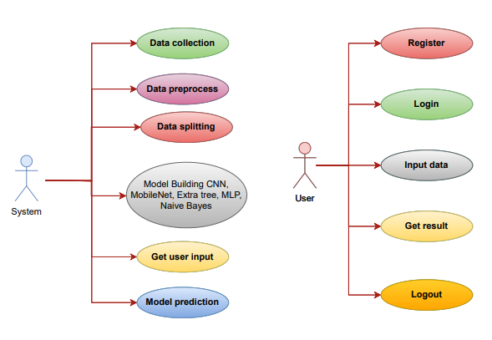

**5.2.2 Class Diagram:**

In software engineering, a class diagram in the Unified Modelling Language (UML) is a type of static structure diagram that describes the structure of a system by showing the system's classes, their attributes, operations (or methods), and the relationships among the classes. It explains which class contains information.

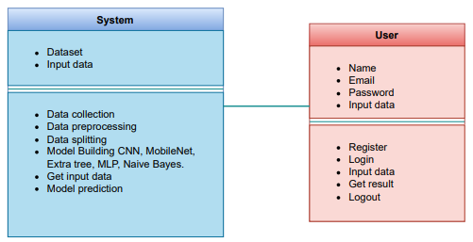

**5.2.3 Sequence Diagram:**

A sequence diagram in Unified Modelling Language (UML) is a kind of interaction diagram that shows how processes operate with one another and in what order. It is a construct of a Message Sequence Chart. Sequence diagrams are sometimes called event diagrams, event scenarios, and timing diagrams.

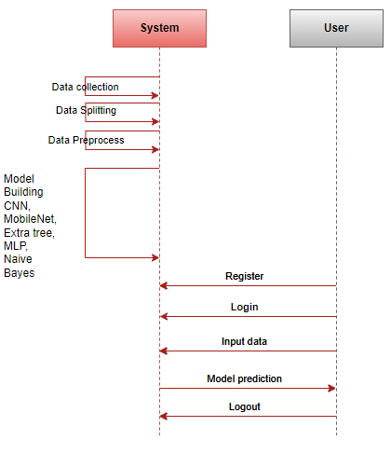

**5.2.4 Collaboration Diagram:**

In collaboration diagram the method call sequence is indicated by some numbering technique as shown below. The number indicates how the methods are called one after another. We have taken the same order management system to describe the collaboration diagram. The method calls are similar to that of a sequence diagram. But the difference is that the sequence diagram does not describe the object organization whereas the collaboration diagram shows the object organization.

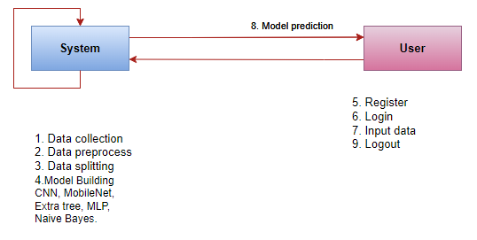

**5.2.5 Deployment 5.2.6 Diagram**

Deployment diagram represents the deployment view of a system. It is related to the component diagram. Because the components are deployed using the deployment diagrams. A deployment diagram consists of nodes. Nodes are nothing but physical hardware’s used to deploy the application.

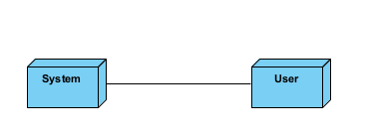

**5.2.7 Activity Diagram:**

Activity diagrams are graphical representations of workflows of stepwise activities and actions with support for choice, iteration and concurrency. In the Unified Modelling Language, activity diagrams can be used to describe the business and operational step-by-step workflows of components in a system. An activity diagram shows the overall flow of control.

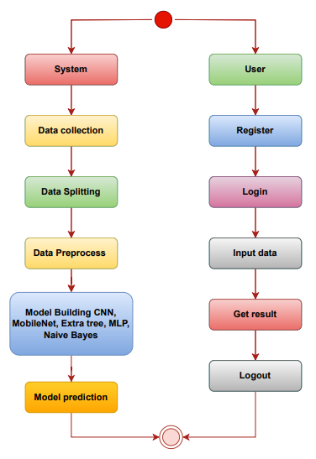

**5.2.8 Component Diagram**:

A component diagram, also known as a UML component diagram, describes the organization and wiring of the physical **c**omponents in a system. Component diagrams are often drawn to help model implementation details and double-check that every aspect of the system's required functions is covered by planned development.

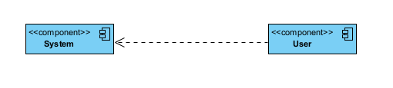

**5.2.9 ER Diagram:**

An Entity–relationship model (ER model) describes the structure of a database with the help of a diagram, which is known as Entity Relationship Diagram (ER Diagram). An ER model is a design or blueprint of a database that can later be implemented as a database. The main components of E-R model are: entity set and relationship set.

An ER diagram shows the relationship among entity sets. An entity set is a group of similar entities and these entities can have attributes. In terms of DBMS, an entity is a table or attribute of a table in database, so by showing relationship among tables and their attributes, ER diagram shows the complete logical structure of a database. Let’s have a look at a simple ER diagram to understand this concept.

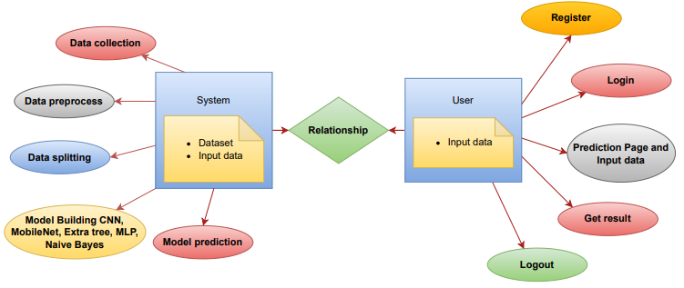

**5.3 DFD Diagram:**

A Data Flow Diagram (DFD) is a traditional way to visualize the information flows within a system. A neat and clear DFD can depict a good amount of the system requirements graphically. It can be manual, automated, or a combination of both. It shows how information enters and leaves the system, what changes the information and where information is stored. The purpose of a DFD is to show the scope and boundaries of a system as a whole. It may be used as a communications tool between a systems analyst and any person who plays a part in the system that acts as the starting point for redesigning a system.

**Level 1 Diagram:**

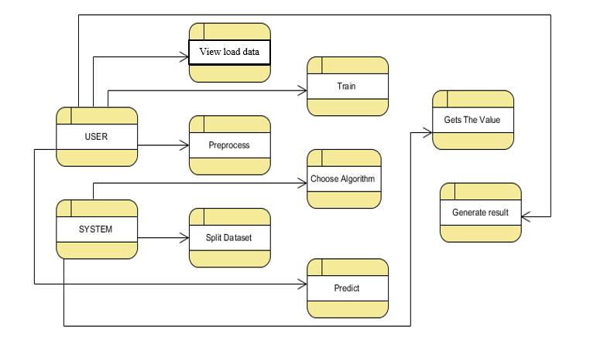

**Level 2 Diagram:**

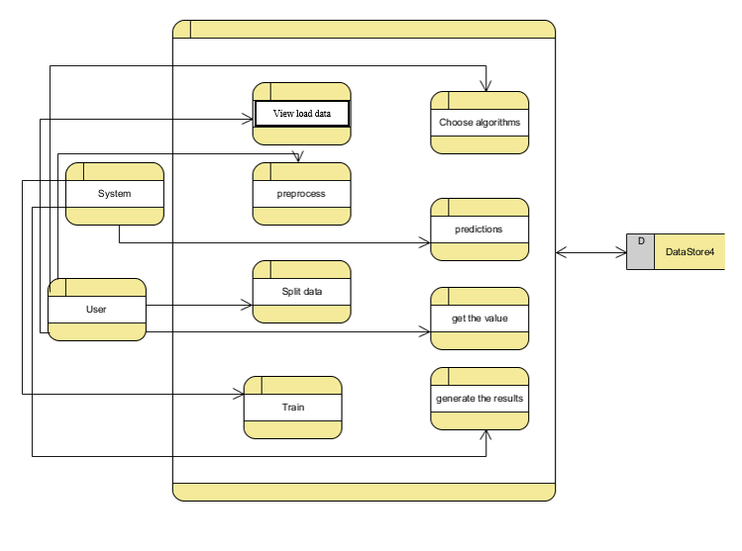

**IMPLEMENTATION AND RESULTS**

**6.1 Modules:**

**System Modules:**

1. **System Data Upload Module:** This module handles the ingestion and storage of patient data, such as medical records, into the system's data.
2. **Data Preprocessing Module:** The system preprocesses the uploaded data, cleaning and transforming it to make it suitable for machine learning analysis.
3. **Algorithm Implementation Module:** It includes the development and integration of the machine learning algorithm or model within the system for disease diagnosis.
4. **Model Evaluation Module:** The system autonomously evaluates the model's performance through validation techniques and metrics to maintain diagnostic accuracy.
5. **Lumpy Disease Prediction:** Provides the final diagnosis for cattle as either LSD-positive or negative based on the implemented algorithms.

**User Modules:**

1. **User Data Upload Module:** Users can upload patient data via the user interface, including images or medical records for diagnosis.
2. **User Data Visualization:** Users can view uploaded data, possibly with additional visualizations and annotations to help understand the diagnosis process.
3. **Diagnosis Results Display:** The user interface presents machine learning-based diagnosis results, showing the predicted disease class and confidence level.
4. **Patient Management:** Users can manage patient records, track the progress of diagnosed cases, and access historical data.
5. **View predicted:** Users can view the predicted result for cattle as either LSD-positive or negative.

**6.2 Algorithms:**

**Extra Tree Classifier:**

Extremely Randomized Trees Classifier (Extra Trees Classifier) is a type of ensemble learning technique which aggregates the results of multiple de-correlated decision trees collected in a “forest” to output it’s classification result. In concept, it is very similar to a Random Forest Classifier and only differs from it in the manner of construction of the decision trees in the forest.

Each Decision Tree in the Extra Trees Forest is constructed from the original training sample. Then, at each test node, Each tree is provided with a random sample of k features from the feature-set from which each decision tree must select the best feature to split the data based on some mathematical criteria (typically the Gini Index). This random sample of features leads to the creation of multiple de-correlated decision trees.

To perform feature selection using the above forest structure, during the construction of the forest, for each feature, the normalized total reduction in the mathematical criteria used in the decision of feature of split (Gini Index if the Gini Index is used in the construction of the forest) is computed. This value is called the Gini Importance of the feature. To perform feature selection, each feature is ordered in descending order according to the Gini Importance of each feature and the user selects the top k features according to his/her choice.

**NAIVE BAYES:**

A Naive Bayes classifier is a probabilistic machine learning model that’s used for classification task. The crux of the classifier is based on the Bayes theorem.

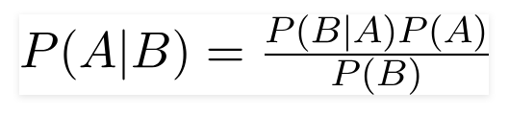

Using Bayes theorem, we can find the probability of **A** happening, given that **B** has occurred. Here, **B** is the evidence and **A** is the hypothesis. The assumption made here is that the predictors/features are independent. That is presence of one particular feature does not affect the other. Hence it is called naive.

Let’s understand it using an example. Below I have a training data set of weather and corresponding target variable ‘Play’ (suggesting possibilities of playing). Now, we need to classify whether players will play or not based on weather condition. Let’s follow the below steps to perform it.

Step 1: Convert the data set into a frequency table

Step 2: Create Likelihood table by finding the probabilities like Overcast probability = 0.29 and probability of playing is 0.64.

[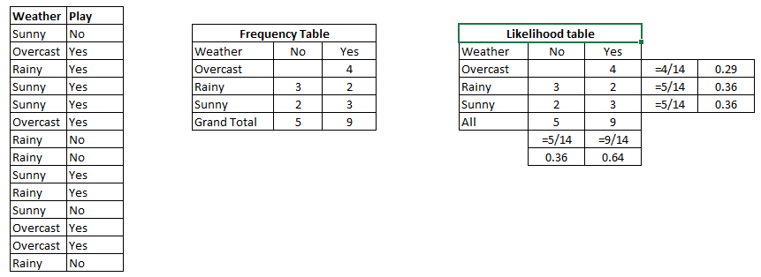](https://www.analyticsvidhya.com/wp-content/uploads/2015/08/Bayes_41.png)

Step 3: Now, use [Naive Bayesian](https://courses.analyticsvidhya.com/courses/naive-bayes?utm_source=blog&utm_medium=naive-bayes-explained) equation to calculate the posterior probability for each class. The class with the highest posterior probability is the outcome of prediction.

Problem**:**Players will play if weather is sunny. Is this statement is correct?

We can solve it using above discussed method of posterior probability.

P(Yes | Sunny) = P( Sunny | Yes) * P(Yes) / P (Sunny)

Here we have P (Sunny |Yes) = 3/9 = 0.33, P (Sunny) = 5/14 = 0.36, P (Yes) = 9/14 = 0.64

Now, P (Yes | Sunny) = 0.33 * 0.64 / 0.36 = 0.60, which has higher probability.

Naive Bayes uses a similar method to predict the probability of different class based on various attributes. This algorithm is mostly used in text classification and with problems having multiple classes.

* It is easy and fast to predict class of test data set. It also perform well in multi class prediction
* When assumption of independence holds, a Naive Bayes classifier performs better compare to other models like logistic regression and you need less training data.
* It perform well in case of categorical input variables compared to numerical variable(s). For numerical variable, normal distribution is assumed (bell curve, which is a strong assumption).

**Applications of Naive Bayes Algorithms**

**Real time Prediction:**Naive Bayes is an eager learning classifier and it is sure fast. Thus, it could be used for making predictions in real time.

**Multi class Prediction:**This algorithm is also well known for multi class prediction feature. Here we can predict the probability of multiple classes of target variable.

**Text classification/ Spam Filtering/ Sentiment Analysis:** Naive Bayes classifiers mostly used in text classification (due to better result in multi class problems and independence rule) have higher success rate as compared to other algorithms. As a result, it is widely used in Spam filtering (identify spam e-mail) and Sentiment Analysis (in social media analysis, to identify positive and negative customer sentiments)

**Recommendation System:**Naive Bayes Classifier and [Collaborative Filtering](https://en.wikipedia.org/wiki/Collaborative_filtering) together builds a Recommendation System that uses machine learning and data mining techniques to filter unseen information and predict whether a user would like a given resource or not

**MULTILAYER PERCEPTRON:**

In the world of deep learning, TensorFlow, Keras, Microsoft Cognitive Toolkit (CNTK), and PyTorch are very popular. Most of us may not realise that the very popular machine learning library **Scikit-learn** is also capable of a basic deep learning modelling

* Salient points of Multilayer Perceptron (MLP) in Scikit-learn
* There is no activation function in the output layer.
* For regression scenarios, the square error is the loss function, and cross-entropy is the loss function for the classification
* It can work with single as well as multiple target values regression.
* Unlike other popular packages, likes Keras the implementation of MLP in Scikit doesn’t support GPU.

We cannot fine-tune the parameters like different activation functions, weight initializers etc. for each layer.

A multilayer perceptron (MLP) is a class of [feedforward](https://en.wikipedia.org/wiki/Feedforward_neural_network) [artificial neural network](https://en.wikipedia.org/wiki/Artificial_neural_network) (ANN). The term MLP is used ambiguously, sometimes loosely to mean any feedforward ANN, sometimes strictly to refer to networks composed of multiple layers of [perceptrons](https://en.wikipedia.org/wiki/Perceptron" \o "Perceptron) (with threshold activation); see [Terminology](https://en.wikipedia.org/wiki/Multilayer_perceptron#Terminology). Multilayer perceptrons are sometimes colloquially referred to as "vanilla" neural networks, especially when they have a single hidden layer.

An MLP consists of at least three [layers](https://en.wikipedia.org/wiki/Layer_(deep_learning)) of nodes: an input [layer](https://en.wikipedia.org/wiki/Layer_(deep_learning)), a hidden [layer](https://en.wikipedia.org/wiki/Layer_(deep_learning)) and an output [layer](https://en.wikipedia.org/wiki/Layer_(deep_learning)). Except for the input nodes, each node is a neuron that uses a nonlinear [activation function](https://en.wikipedia.org/wiki/Activation_function). MLP utilizes a [supervised learning](https://en.wikipedia.org/wiki/Supervised_learning) technique called [backpropagation](https://en.wikipedia.org/wiki/Backpropagation) for training. Its multiple layers and non-linear activation distinguish MLP from a linear [perceptron](https://en.wikipedia.org/wiki/Perceptron). It can distinguish data that is not [linearly separable](https://en.wikipedia.org/wiki/Linear_separability)

The term "multilayer perceptron" does not refer to a single perceptron that has multiple layers. Rather, it contains many perceptrons that are organized into layers. An alternative is "multilayer perceptron network". Moreover, MLP "perceptrons" are not perceptrons in the strictest possible sense. True perceptrons are formally a special case of artificial neurons that use a threshold activation function such as the [Heaviside step function](https://en.wikipedia.org/wiki/Heaviside_step_function). MLP perceptrons can employ arbitrary activation functions. A true perceptron performs binary classification, an MLP neuron is free to either perform classification or regression, depending upon its activation function.

The term "multilayer perceptron" later was applied without respect to nature of the nodes/layers, which can be composed of arbitrarily defined artificial neurons, and not perceptrons specifically. This interpretation avoids the loosening of the definition of "perceptron" to mean an artificial neuron in general.

MLPs are useful in research for their ability to solve problems stochastically, which often allows approximate solutions for extremely [complex](https://en.wikipedia.org/wiki/Computational_complexity_theory) problems like [fitness approximation](https://en.wikipedia.org/wiki/Fitness_approximation).

MLPs are universal function approximates as shown by [Cybenko's theorem](https://en.wikipedia.org/wiki/Universal_approximation_theorem" \o "Universal approximation theorem), so they can be used to create mathematical models by regression analysis. As [classification](https://en.wikipedia.org/wiki/Statistical_classification) is a particular case of [regression](https://en.wikipedia.org/wiki/Regression_analysis) when the response variable is [categorical](https://en.wikipedia.org/wiki/Categorical_variable), MLPs make good classifier algorithms.

MLPs were a popular machine learning solution in the 1980s, finding applications in diverse fields such as [speech recognition](https://en.wikipedia.org/wiki/Speech_recognition), [image recognition](https://en.wikipedia.org/wiki/Image_recognition), and [machine translation](https://en.wikipedia.org/wiki/Machine_translation) software, but thereafter faced strong competition from much simpler  [support vector machines](https://en.wikipedia.org/wiki/Support_vector_machine). Interest in backpropagation networks returned due to the successes of [deep learning](https://en.wikipedia.org/wiki/Deep_learning).

**CNN (Convolutional Neural Network)**

Convolutional Neural Networks (CNNs) are a class of deep learning algorithms designed to process and classify image data. CNNs work by passing input images through a series of convolutional layers, where filters or kernels are applied to detect various features, such as edges, textures, and shapes. After convolution, the feature maps are often pooled to reduce spatial dimensions, followed by fully connected layers that help in the final classification. The network learns the most important features during training through backpropagation, adjusting weights to minimize classification error. CNNs are particularly effective at capturing hierarchical patterns in images, making them suitable for tasks like image classification, object detection, and medical image analysis, such as detecting Lumpy Skin Disease in cattle.

**MobileNet**

MobileNet is a lightweight deep learning architecture designed for efficient image classification, particularly in mobile and embedded devices where computational resources are limited. Unlike traditional CNNs, MobileNet utilizes depthwise separable convolutions, which separate the convolution operation into two parts: a depthwise convolution (applied to each input channel independently) and a pointwise convolution (a 1x1 convolution that combines the outputs). This technique significantly reduces the number of parameters and computations, making MobileNet faster and more efficient without sacrificing too much accuracy. It is particularly useful in real-time applications where speed and resource efficiency are crucial, such as mobile devices and edge computing, allowing for effective image classification in scenarios like detecting Lumpy Skin Disease in cattle.

**OUTPUT SCREENS:**

**Home Page:** Here user view the home page of Machine Learning Based Diagnosis of Lumpy Skin Disease web application.

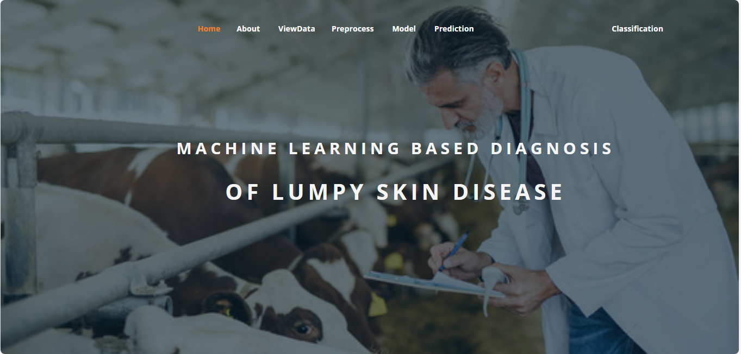

**ABOUT PAGE:** Here we can read about our project.

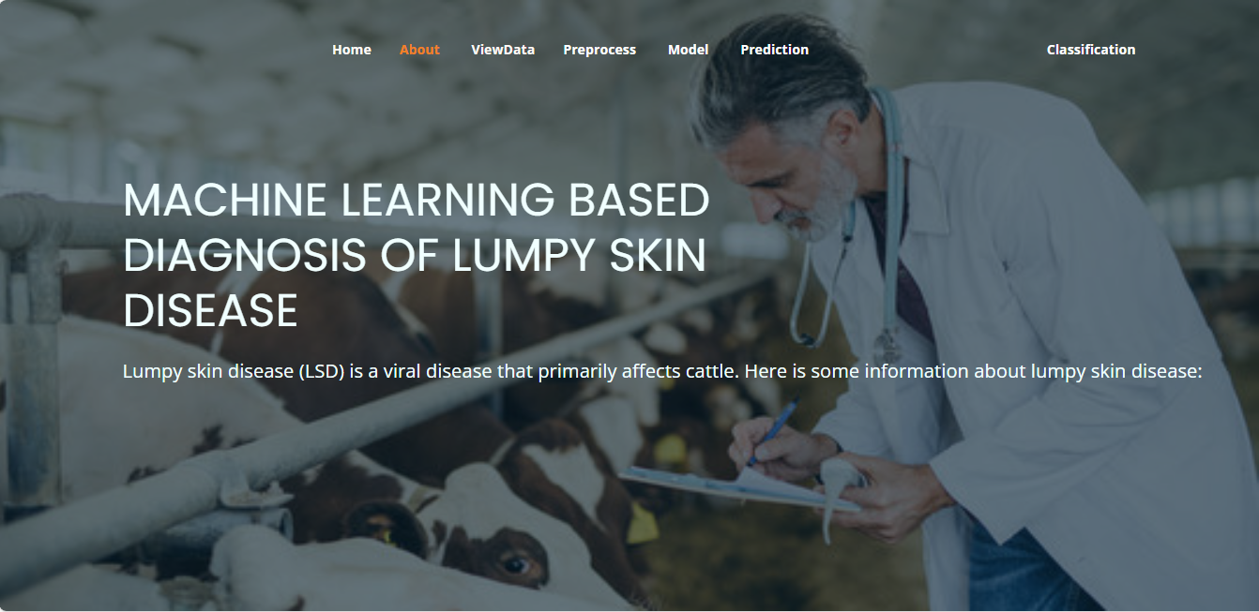

**View Data:** In the Viewdata page, users can view the skin dataset.

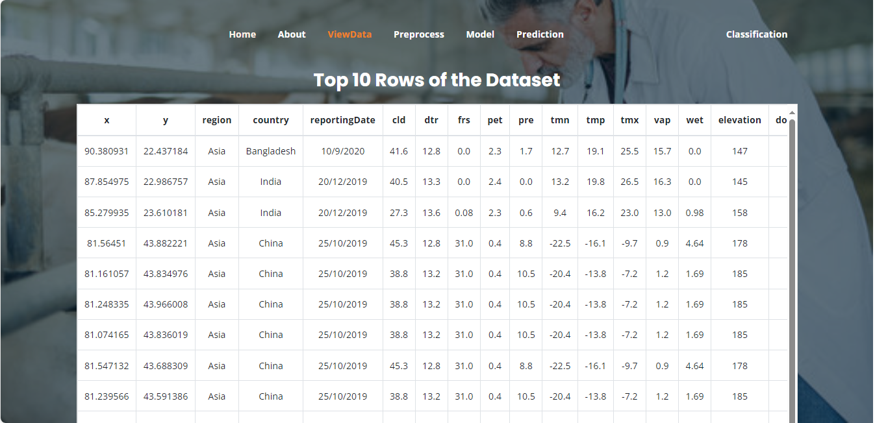

**Pre-process:** Here we can pre-process and split our data into train and test.



**Model:** Here we train our data with different ML algorithms.



**Prediction:** This page show the result of the user given input data.

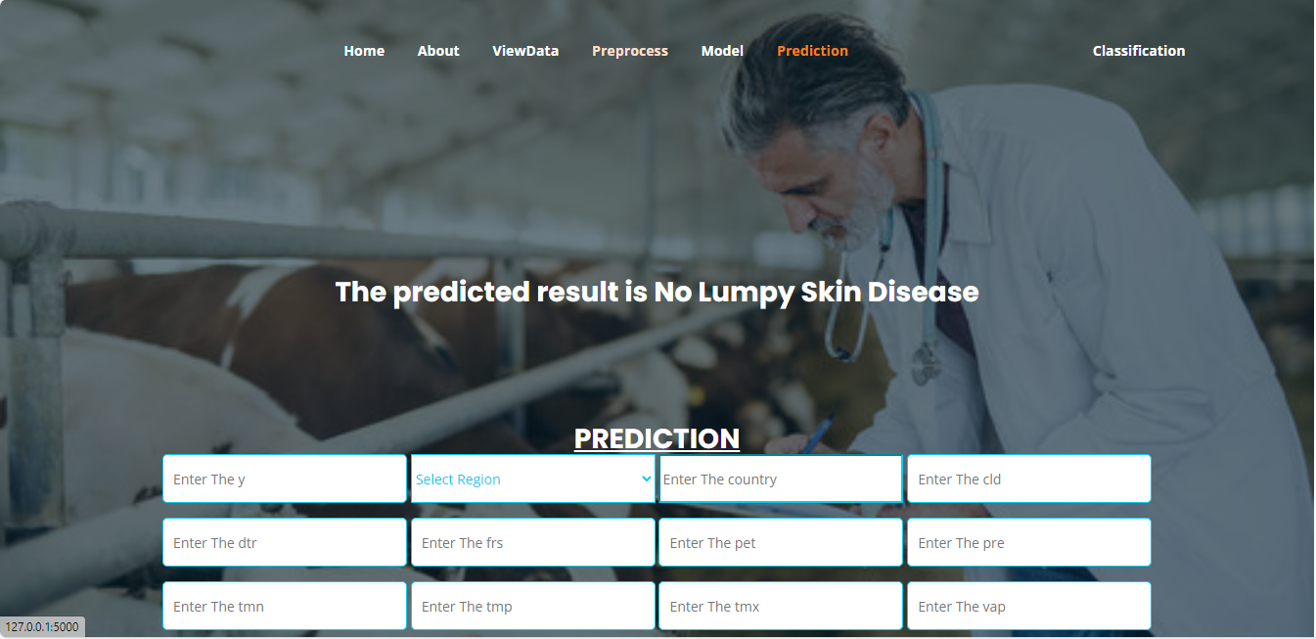

**Classification:** This page show the result of the user given image.



**7. SYSTEM STUDY AND TESTING**

**7.1 Feasibility Study**

The feasibility of the project is analysed in this phase and business proposal is put forth with a very general plan for the project and some cost estimates. During system analysis the feasibility study of the proposed system is to be carried out. This is to ensure that the proposed system is not a burden to the company. For feasibility analysis, some understanding of the major requirements for the system is essential.

Three key considerations involved in the feasibility analysis are

* Economical feasibility
* Technical feasibility
* Social feasibility

**Economical Feasibility**

This study is carried out to check the economic impact that the system will have on the organization. The amount of fund that the company can pour into the research and development of the system is limited. The expenditures must be justified. Thus the developed system as well within the budget and this was achieved because most of the technologies used are freely available. Only the customized products had to be purchased.

### **Technical Feasibility**

This study is carried out to check the technical feasibility, that is, the technical requirements of the system. Any system developed must not have a high demand on the available technical resources. This will lead to high demands on the available technical resources. This will lead to high demands being placed on the client. The developed system must have a modest requirement, as only minimal or null changes are required for implementing this system.

**Social Feasibility**

The aspect of study is to check the level of acceptance of the system by the user. This includes the process of training the user to use the system efficiently. The user must not feel threatened by the system, instead must accept it as a necessity. The level of acceptance by the users solely depends on the methods that are employed to educate the user about the system and to make him familiar with it. His level of confidence must be raised so that he is also able to make some constructive criticism, which is welcomed, as he is the final user of the system.

**System Testing**

The purpose of testing is to discover errors. Testing is the process of trying to discover every conceivable fault or weakness in a work product. It provides a way to check the functionality of components, sub-assemblies, assemblies and/or a finished product It is the process of exercising software with the intent of ensuring that the

Software system meets its requirements and user expectations and does not fail in an unacceptable manner. There are various types of test. Each test type addresses a specific testing requirement.

**7.2 Types of Tests**

**7.2.1 Unit testing**

Unit testing involves the design of test cases that validate that the internal program logic is functioning properly, and that program inputs produce valid outputs. All decision branches and internal code flow should be validated. It is the testing of individual software units of the application .it is done after the completion of an individual unit before integration. This is a structural testing, that relies on knowledge of its construction and is invasive. Unit tests perform basic tests at component level and test a specific business process, application, and/or system configuration. Unit tests ensure that each unique path of a business process performs accurately to the documented specifications and contains clearly defined inputs and expected results.

**7.2.2 Integration testing**

Integration tests are designed to test integrated software components to determine if they actually run as one program. Testing is event driven and is more concerned with the basic outcome of screens or fields. Integration tests demonstrate that although the components were individually satisfaction, as shown by successfully unit testing, the combination of components is correct and consistent. Integration testing is specifically aimed at exposing the problems that arise from the combination of components.

Software integration testing is the incremental integration testing of two or more integrated software components on a single platform to produce failures caused by interface defects.

The task of the integration test is to check that components or software applications, e.g. components in a software system or – one step up – software applications at the company level – interact without error.

**Test Results:** All the test cases mentioned above passed successfully. No defects encountered.

**Acceptance Testing**

User Acceptance Testing is a critical phase of any project and requires significant participation by the end user. It also ensures that the system meets the functional requirements.

**Test Results:** All the test cases mentioned above passed successfully. No defects encountered.

**7.2.3 Functional testing**

Functional tests provide systematic demonstrations that functions tested are available as specified by the business and technical requirements, system documentation, and user manuals.

Functional testing is centered on the following items:

Valid Input : identified classes of valid input must be accepted.

Invalid Input : identified classes of invalid input must be rejected.

Functions : identified functions must be exercised.

Output : identified classes of application outputs must be exercised.

Systems/Procedures: interfacing systems or procedures must be invoked.

Organization and preparation of functional tests is focused on requirements, key functions, or special test cases. In addition, systematic coverage pertaining to identify Business process flows; data fields, predefined processes, and successive processes must be considered for testing. Before functional testing is complete, additional tests are identified and the effective value of current tests is determined.

**7.2.4 White Box Testing**

White Box Testing is a testing in which in which the software tester has knowledge of the inner workings, structure and language of the software, or at least its purpose. It is purpose. It is used to test areas that cannot be reached from a black box level.

**7.2.5 Black Box Testing**

Black Box Testing is testing the software without any knowledge of the inner workings, structure or language of the module being tested. Black box tests, as most other kinds of tests, must be written from a definitive source document, such as specification or requirements document, such as specification or requirements document. It is a testing in which the software under test is treated, as a black box .you cannot “see” into it. The test provides inputs and responds to outputs without considering how the software works.

**Test objectives**

* All field entries must work properly.
* Pages must be activated from the identified link.
* The entry screen, messages and responses must not be delayed.

**Features to be tested**

* Verify that the entries are of the correct format
* No duplicate entries should be allowed
* All links should take the user to the correct page.
* **TEST CASES:**
* **TEST CASES:**

|  |  |  |
| --- | --- | --- |
| **Input** | **Output** | **Result** |
| Input | Tested for different model given by user on the different model. | Success |
| Naive Bayes | Tested for different input given by the user on different models are created using the different algorithm and data. | Success |
| Prediction | Prediction will be performed using to build from the algorithm. | Success |

* **Test cases Model building:**

|  |  |  |  |  |  |
| --- | --- | --- | --- | --- | --- |
| **S.NO** | **Test cases** | **I/O** | **Expected O/T** | **Actual O/T** | **P/F** |
| 1 | Read the datasets. | Dataset’s path. | Datasets need to read successfully. | Datasets fetched successfully. | It produced P. If this not F will come |
| 2 | Verifying Machine Learning Based Diagnosis of Lumpy Skin  Disease | Machine Learning Based Diagnosis of Lumpy Skin  Disease | Output as either in the form cases | Output is classified as cases | It produced P. If this is not, it will undergo F |
| 3 | Verifying Machine Learning Based Diagnosis of Lumpy Skin  Disease | Input for Machine Learning Based Diagnosis of Lumpy Skin  Disease | Output as either in the form cases | Output is classified cases | It produced P. If this is not, it will undergo F |
| 4 | Verifying Machine Learning Based Diagnosis of Lumpy Skin  Disease | Input the result | Need to predict the best Accuracy | Model successfully predicted  Accuracy | It produced P. If this is not, it will undergo F |

**8. CONCLUSION**

The novelty in our Machine Learning-Based Diagnosis of Lumpy Skin Disease stems from a dual-layered, multi-algorithmic strategy that integrates both deep learning and traditional machine learning. First, we harness Convolutional Neural Networks (CNNs) such as MobileNet to classify buffalo skin images, effectively identifying features that may signal Lumpy Skin Disease. In parallel, we leverage CSV-based clinical or diagnostic features and feed them into a diverse ensemble of algorithms, including Multilayer Perceptrons (MLP), Extra Trees, and Naive Bayes. By capitalizing on the complementary strengths of these state-of-the-art methods, our approach achieves higher robustness, accuracy, and adaptability compared to systems that rely on a single classifier. This fusion of deep learning image analysis with an ensemble of machine learning models enables more precise and reliable diagnoses, ultimately benefiting both patients and healthcare professionals in the context of Lumpy Skin Disease.

**9. FUTURE ENHANCEMENT**

Future enhancements for the machine learning-based diagnosis of Lumpy Skin Disease (LSD) could include the integration of advanced computer vision techniques to improve the accuracy of lesion detection and classification. Additionally, incorporating real-time data from wearable devices or remote sensing technologies could enable earlier detection and monitoring of LSD in livestock. Furthermore, the development of a user-friendly mobile application for farmers and veterinarians to input and access data could facilitate quicker and more widespread diagnosis and management of the disease, ultimately improving animal health and reducing economic losses.

**10. REFERANCES**

[1] Bakker, Mykola Pechenizkiy, Natalia Sidorova , What’s your current stress level? Detection of stress patterns from GSR sensor data, 2011 11th IEEE International Conference on Data Mining Workshops,  
Department of Computer Science Eindhoven University of Technology, 978-0-7695-4409-0/11 $26.00 © 2011 IEEE DOI 10.1109/ICDMW.2011.17  
[2] J. Clerk Maxwell, A Treatise on Electricity and Magnetism, 3rd ed., vol. 2. Oxford: Clarendon, 1892, pp.68–73.  
[3] I. S. Jacobs and C. P. Bean, “Fine particles, thin films and exchange anisotropy,” in Magnetism, vol. III, G. T. Rado and H. Suhl, Eds. New York: Academic, 1963, pp. 271–350.  
[4] K. Elissa, “Title of paper if known,” unpublished.  
[5] R. Nicole, “Title of paper with only first word capitalized,” J. Name Stand. Abbrev., in press.  
[6] Y. Yorozu, M. Hirano, K. Oka, and Y. Tagawa, “Electron spectroscopy studies on magneto-optical media and plastic substrate interface,” IEEE Transl. J. Magn. Japan, vol. 2, pp. 740–741, August 1987  
[Digests 9th Annual Conf. Magnetics Japan, p. 301, 1982].  
[7] M. Young, The Technical Writer’s Handbook. Mill Valley, CA: University Science, 1989.  
[8] G. Eason, B. Noble, and I. N. Sneddon, “On certain integrals of Lipschitz-Hankel type involving products of Bessel functions,” Phil. Trans. Roy. Soc. London, vol. A247, pp. 529–551, April 1955.  
(references).  
[9] UnsuKristina P. Sinaga and Miin-Shen Yang, pervised K-Means Clustering Algorithm , 2018 IEEE International Symposium on Smart Electronic Systems (iSES) (Formerly iNiS).  
[10] Jirong Gu, Jieming Zhou Xianwei Chen Xianwei Chen, An Enhancement of K-means Clustering Algorithm, 2009 International Conference on Business Intelligence and Financial Engineering.  
[11] V Sasikala; T Rajeswari; Sk Naseema Begum; Ch Divya Sri; M Sravya, Stress Detection from Sensor Data using Machine Learning Algorithms,16-18 March 2022-21688590.  
[12] Prithwijit Mukherjee,Dr.Anisha Halder Roy,Detection of Stress in Human Brain ,2019 Second International Conference on Advanced Computational and Communication Paradigms (ICACCP)